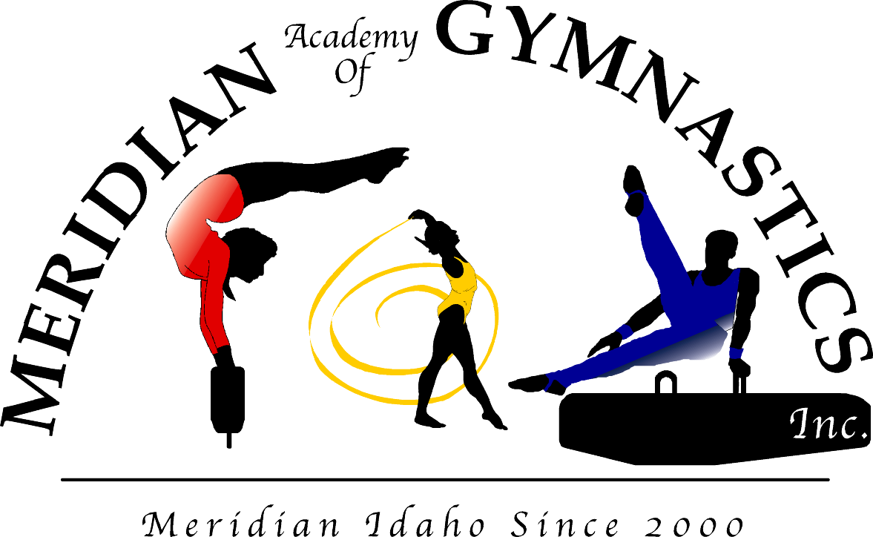

Dear Parents,

Welcome to Meridian Academy of Gymnastics, Inc.! Congratulations for caring enough to be investing in your child’s future physical development. We are pleased you have chosen our facility for your child. We pledge to uphold our philosophy which is to exercise your child’s body and mind in a fun, safe environment, while encouraging the development of their self-esteem! Our entire staff and all of our programs are guided by this philosophy.

We have provided you with some very important information about our policies, along with the best place to have your Birthday Party, Super Gym information, a calendar of upcoming events, a bi-monthly newsletter and more. We have also included schedules of all the programs we offer: Gymnastics, which includes our competitive team, adult classes, and Tumble & Trampoline classes, a complete Dance program, our awesome All-Star Cheer program, Taekwon-Do Karate, and adult fitness.

Please take time to read through all the information. If you have questions or concerns please feel free to talk with either the coaching staff or the office staff. We will be glad to answer any questions.

Thank you for supporting our programs! The staff at Meridian Academy of Gymnastics, Inc. is looking forward to working with you and your children!

These are a few helpful hints!
-New students should always have a name tag.
-Please make sure your child is dressed in comfortable clothing; no zippers, buttons, or pins.
-For gymnastics, girls should wear a leotard and the feet should always be bare.
-For dance, you will need the required shoes for your class. Please talk to the instructor about proper dance attire.
-For cheer, they will need to wear athletic tennis shoes and comfortable clothing.
-Hair should always be tied back neatly away from the face.
-No food, drink, or gum allowed outside the observation area.
-Please wait in the observation area until the instructor calls your child out to class.
-All children must wait inside the building for their ride after class.

Have a GREAT DAY!

Colleen Kelly

RULES & POLICIES

Drop Policy
Payments are due at the beginning of the month. If you are planning to take (1) or more months off from classes you MUST notify our office in writing by the end of the month prior to the start of the month in which you will not be enrolled.
Please fill out the “Drop Form” provided to you in the office and put it in the payment box, mail it to the gym, or hand it to the office staff only. DO NOT hand it to your child’s coach. Without written notice, we will assume you are still enrolled in class and you will be charged for each month until we receive your written drop notification. Accounts not paid in full will be turned over to collections. **NOTICE: Taking time off without full monthly payment will not reserve your child’s space in class.I HAVE READ, UNDERSTAND, AND AGREE TO THE TERMS OF THE DROP POLICY. IF I DO NOT FILL OUT A DROP FORM I ACKNOWLEDGE THAT I AM RESPONSIBLE FOR PAYMENT OF THE FULL MONTHLY TUITION FOR MY CHILD.

Payment Policy
All payments are due by the 25th of the previous month in order to receive the “Early Payment Discount” and one free hour of Super Gym. Payments after the 25th of the previous month must pay the “Regular Payment”. There is a $5.00 LATE FEE on payments received after the 10th of the month.
Payments will be accepted in the form of cash, check, money order, or accepted credit cards only. Monthly tuition is NON-REFUNDABLE.
The annual registration fee is due when you enroll into the program as a member. This fee is NON-REFUNABLE. The registration fee is good for one year (Sept.-Sept.). You do not have to re-register if you drop out and return within that year. You will receive notice when your registration fee expires. Registration must be current to stay enrolled.
We do not allow make-up classes to be made in months in which we have not received the full monthly payment. You will not be able to participate if you are not currently enrolled as a student. You must pay for the entire month of classes.
Make-up classes or missed classes cannot be carried over as credit towards the next month. You must pay for the entire month of classes.
Payments for individual classes or drop-ins are not permitted. Only full monthly payments will be accepted.
There will be a $20.00 penalty for all returned checks.
Your full monthly payment is to guarantee your child’s space in his/her class. It is your responsibility to make up any missed classes.
**ATTENTION TEAM: Any gymnast on Meridian Academy of Gymnastics, Inc competitive boys or girls teams must make full payment every month to maintain their team status regardless of attendance.

Make Up Policy
Make-ups can be completed in two ways. The student may attend another class of their level during the week or attend Super Gym. In order to complete make-ups for missed classes, the participant MUST be currently enrolled in a class.
Make-ups must be completed within two months of the missed class(es).
To do a make-up in another class during the week you must make arrangements in advance by calling or stopping by the gym office. If you come to make up a class without prior notice, you may be turned away to prevent overcrowding a full class.
Due to limited space, if you schedule a make-up and are a “NO SHOW” it will be counted as a make-up. To cancel a scheduled make-up you must notify our office at least 8 hours before the start of the class.
To attend Super Gym you must sign up in advance by the office. Please check to see when they will be scheduled. PLEASE

Thank you for supporting our programs and for your cooperation.
Colleen Kelly

*NO REFUNDS, SORRY FOR ANY INCONVIENCE!

Scheduled Gym Closings

January 1st – New Year’s Day September – Labor Day Weekend
(Saturday thru Monday)

May – Memorial Day November – Thanksgiving
(Saturday thru Monday) (Thursday thru Saturday)

July 4th – Independence Day December – Christmas Break (December 24th-31st)

